ISM 665: Principles of Cyber Security

Fall 2025
The University of North Carolina at Greensboro
Information Systems and Supply Chain Management Department

Professor: | Dr. Moez Farokhnia Hamedani | Phone: | (813)-465-8525
Office: | 423 Bryan Building | Email: | M_farokhnia@uncg.edu
Class time: | Thursday 6:30-9:30 | Website: | canvas.uncg.edu
Classroom: | Bryan Building (216) for in-person section, Via Teams for the online Section
Office Hours: Tuesday 10:00_12:00 (Via Teams): Link of the office hours Teams meeting is posted on Canvas.
Additional appointments (online or in-person) can be scheduled via email.
Prerequisite: None.

Catalog Description:
Study of the technical, managerial, and organization issues in systems security, including systems security models, analysis of business process and technology for systems security, and information assurance.

Detailed Description:
This course provides students with insight into the cybersecurity issues surrounding an enterprise. These include securing organizational data, responding to cyber-based security breaches, emerging technologies, and ensuring a secured computing environment for safeguarding company information. The course reviews the network security and cryptographic techniques that are currently being used. The nuances involved in defining cybersecurity strategies and complying with security standards to ensure governance are also discussed.
This course offers a practical approach to cybersecurity, focusing on hands-on experience in areas such as threat detection, prevention, and mitigation. The textbook specifically prepares students for one of the highly regarded cybersecurity certifications known as "CompTIA Security+." By successfully completing this course, students will be well-prepared to take the certification exam and pursue this prestigious credential. Hence, the major focus of this course is on the virtual labs within each module.

Course Learning Objectives:
- Understanding fundamental principles of cybersecurity analysis, including threat intelligence, vulnerability management, and incident response.
- Identifying and analyzing security threats, including malware, social engineering attacks, and insider threats.
- Developing incident response plans, including containment, eradication, and recovery strategies.
- Conducting risk assessments and implementing risk mitigation strategies.
- Understanding legal and ethical considerations in cybersecurity, including privacy laws and professional responsibilities.

Required Texts/Readings (please check https://bookstore.uncg.edu/ for further information):

This option is recommended for those of you who are enrolled in the “First Day Complete” program.

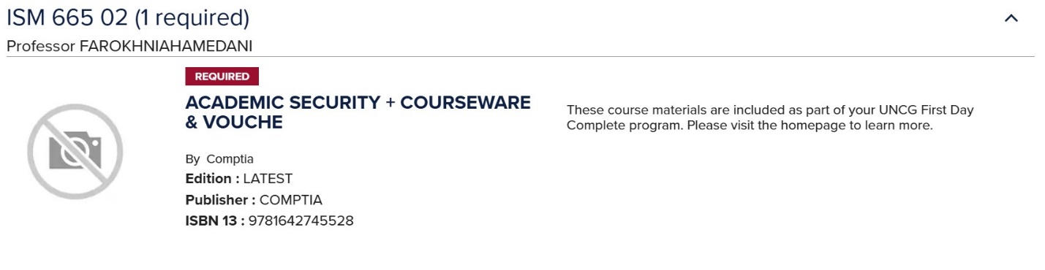

An alternative option is available for students who have opted out of the First Day Complete program.
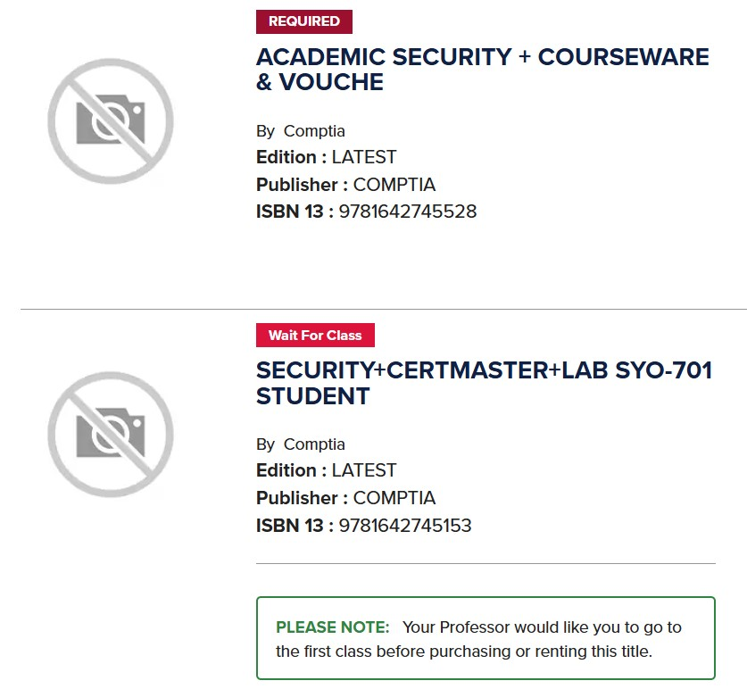

Additional readings provided on Canvas.

Laptop and Canvas Learning Management System
This class will utilize a combination of the Canvas system and ComTIA’s LabSim platform for the distribution of materials, communications, submission of homework, and examinations. Students should get familiar with Canvas (canvas.uncg.edu) and LabSim (https://labsimapp.testout.com/v6_0_608/index.html) as soon as possible. Check Canvas postings and your email at least once a day.

Performance Evaluation:
All individual assignments (Virtual Labs, Quizzes, Exercises and bonus questions) must be done by only you. Individuals should not work on these assignments together. Students may seek the general advice of others (any student or faculty), but at no time should a student seek or accept the answer to an assignment exercise from anyone else. A single failure to follow this policy will result in a grade of 0 on that assignment; subsequent violations of this policy will result in a grade of F for the course. Please ask the instructor if you have questions about this policy, prior to seeking the advice or direction of another person.

The course grade will be based on the following distribution:

 | Assignment | Grade
1 | Virtual Labs | 45 points
2 | Quizzes | 45 points
3 | Discussions | 10 points
4 | Bonus Points | 10 points
 | Total | 100+10 points

Virtual Labs: The main objective of this course is to provide students with hands-on cybersecurity experiences. Each module is accompanied by multiple virtual labs specifically designed for that chapter, enabling them you to gain practical, real-world cybersecurity skills. The virtual labs provide step-by-step guidelines to navigate you through the machines and successfully complete the assignments. It is essential to carefully watch the training provided at the start of each lab and diligently follow the instructions.

Quizzes: Each module includes several sets of short quizzes, each consisting of 10 questions and covering a specific subset of the chapter's topic. Based on the total number of quizzes, the importance of the topic, and the number of virtual labs, I will select 1 to 3 quizzes from each chapter to be mandatory. These selected quizzes are mandatory and will count toward your final score. If you receive a low score on the mandatory quizzes, you have the opportunity to improve your grade by taking an extra quiz from the remaining optional quizzes in the chapter. I will then drop your lowest score. For example, if a chapter has five quizzes and two are mandatory, and you score 60% on one of them, you can take one of the three remaining quizzes. If your score on the additional quiz is higher than 60%, I will replace your previous score with the new one.
These quizzes carry significant weight in determining your final grades and provide an opportunity to thoroughly review the module content. Since regular testing occurs on a weekly basis, there will be no mid-term or final exam. It is crucial to review the course materials thoroughly before attempting each quiz. Please note that you will have only one attempt for each quiz, and they must be completed before the specified deadlines.
Discussions: Upon completing each chapter, I will post a question or topic on Canvas for you to discuss. It is essential that your responses to the discussion questions are based on your understanding and knowledge. You may seek help from Generative AI (GAI) tools such as ChatGPT to broaden your knowledge or deepen your understanding. However, it is critical to submit the prompt you used to reach your final response. You cannot directly copy the discussion question into ChatGPT and submit its response, as this will result in a grade of 0. Instead, you can engage in a meaningful discussion with ChatGPT, seek its advice, or use its insights to formulate your response. For example, if you ask ChatGPT about a concept or topic you are not familiar with, it is important to submit the thread of your conversation with the GAI tool that led to your final solution. Otherwise, no points will be awarded for your response. Additionally, using GAI tools to edit your answers is encouraged.
Bonus Points: As previously mentioned, this course aims to adequately prepare students for the esteemed CompTIA Security+ certification exam. Therefore, it is crucial for students to be thoroughly tested on the core topics covered throughout the textbook. At the end of the semester, I will provide a set of comprehensive quizzes covering all the topics addressed during the semester. These quizzes will be accessible for a period of 10 days, allowing students to choose a suitable time within that window to complete them.
You can take up to 4 quizzes, and I will select the top 2 scores for a chance to earn up to 10 bonus points. Please note that these quizzes are optional, and choosing not to take them will not result in any loss of points.

General Evaluation and Grading Criteria:
Final grades will be assigned based on the total points earned according to the following scale:
100 – 94 | = | A | 76 – 73 | = | C
93 – 90 | = | A- | 72 – 70 | = | C-
89 – 87 | = | B+ | 69 – 67 | = | D+
86 – 83 | = | B | 66 – 63 | = | D
82 – 80 | = | B- | 62 – 60 | = | D-
79 – 77 | = | C+ | Below 60 | = | F

The following criteria will apply to the grading of assignments.
A: Work that demonstrates not only a clear understanding of the material under study, but also a superior ability to utilize that material in the assignment. All criteria are met. The student’s work goes beyond the task and contains additional, unexpected or outstanding features.
B: Work that demonstrates a good understanding of the material under study and utilizes the material well in the assignment. The student meets the assignment criteria, with few errors or omissions.
C: Work that minimally demonstrates a basic or technical understanding of the material under study and uses some relevant material in the assignment. Work may not address one or more criteria or may not accomplish what was asked.
F: Work that is incomplete, inappropriate and/or shows little or no comprehension of the material under study.

Late Submissions:
All assignments (Labs and quizzes) must be submitted before the deadline. Missing the deadline will result in 20% penalty. All assignments that are submitted after the deadline will receive 80% of their grades.

Academic Integrity Policy:
All students are required to follow the provisions of the UNCG Academic Integrity Policy in completing course work (http://academicintegrity.uncg.edu). If you do not know the provisions of the Integrity Policy, make time to study it. Plagiarism is not allowed and will have severe consequences.
Students are responsible for becoming familiar with the Academic Integrity Policy in all its aspects and for indicating their knowledge and acceptance of the Policy by signing the Academic Integrity pledge on all major work submitted for the course.

Electronic Mail and Canvas Accounts:
You should check your UNCG email and Canvas regularly (at least once a day) as I will send email updates and add new information on Canvas on a regular basis. You will be responsible for any information or announcements in email messages or updates on Canvas. Do not use Canvas to send emails to me (I do not always get them); instead use your own UNCG email system to send me messages at m_farokhnia@uncg.edu. Start the subject line with ISM 665-01 and include your full name in the email.

Class Schedule:
The following schedule provides a general overview of the class throughout the semester. Each module will be updated on a weekly basis and recorded lectures will be posted on Canvas every week. The table displays the starting date of each week.

Week | Topic | Chapter | Assignment Due
August 21 | Class Overview,  Module 1: Security Concepts | 1
August 28 | Module 2: Threats, Vulnerabilities, and Mitigations | 2 | Module 1
September 4 | Module 3: Cryptographic Solutions | 3 | Module 2
September 11 | Module 4: Identity and Access Management_1 | 4 | Module 3
September 18 | Module 4: Identity and Access Management_2 | 4 | Module 4-1
September 25 | Module 5: Network Architecture_1 | 5 | Module 4-2
October 2 | Module 5: Network Architecture_2 | 5 | Module 5-1
October 9 | Module 6: Resiliency and Site Security_1 | 6 | Module 5-2
October 16 | Module 6: Resiliency and Site Security_2 | 6 | Module 6-1
October 23 | Module 7: Vulnerability Management | 7 | Module 6-2
October 30 | Module 8: Network and Endpoint Security_1 | 8 | Module 7
November 7 | Module 8: Network and Endpoint Security_2 | 8 | Module 8-1
November 14 | Module 9: Incident Response | 9 | Module 8-2
November 21 | Module 11: Security Governance Concepts | 11 | Module 9
November 28 | Thanksgiving Break |  | Module 11  Module 12
December 4 | Module 12: Risk Management | 12

The dates for topics covered and due dates for assignments are subject to change. If there are changes to any of the dates, they will be discussed in the lecture videos as well as announced via Canvas. Note: See the Student Section of the Bryan School website for additional information about “Faculty and Student Guidelines”. https://bryan.uncg.edu/wp-content/uploads/2017/08/faculty- and-student-guidelines-2018.pdf

UNCG Generative AI Academic Integrity Policy:
You are expected to follow the University’s Academic Integrity Policy. All ideas, text, images, and other content you submit should be appropriately cited when taken, directly or indirectly, from another source. For purposes of this course, use of generative artificial intelligence (GAI) will be treated analogously to assistance from another person. Unauthorized or unacknowledged collaboration, or the presentation of another’s work as your own, is a violation of the Academic Integrity Policy. If you are unsure about whether particular uses of GAI tools may be plagiarism, cheating, or another form of academic dishonesty, please reach out to me to discuss it as soon as possible.

Given the hands-on nature of this course, students are encouraged to use Generative AI (GAI) tools to learn more about the topics, jargon, and any other aspects of the course material that may require further elaboration. You are welcome to use GAI tools to complete your lab activities. However, the use of GAI tools such as ChatGPT is strictly prohibited during the multiple-choice quizzes. These quizzes are designed to assess your personal understanding of the topics covered in each chapter, rather than the AI's proficiency. It is expected that students will adhere to this restriction when taking quizzes. For the discussion sections, you are encouraged to use AI as a mentor by asking insightful questions to deepen your understanding. However, you must submit the entire thread of prompts and questions you have asked GAI tools which has led to your final response. Submitting the AI generated responses without citing them or including the prompts will result in penalty.

Accommodations/ADA Statement (We would suggest you use statement below)
UNCG seeks to comply fully with the Americans with Disabilities Act (ADA). Students requesting accommodations based on a disability must connect with the Office of Accessibility Resources and Services (OARS) in 215 Elliott University Center, (336)334-5440, oars.uncg.edu.

Health and Wellness Statement
Your health impacts your learning. Throughout your time in college, you may experience a range of health issues that can cause barriers to your learning. These might include physical ailments, illnesses, strained relationships, anxiety, high levels of stress, alcohol/drug problems, feeling down, or loss of motivation. Student Health Services and The Counseling Center can help with these or other issues you may be experiencing. You can learn about the free, confidential mental health services available on campus by calling 336-334-5874, visiting the website at https://shs.uncg.edu/ or visiting the Anna M. Gove Student Health Center at 107 Gray Drive. Help is always available.

