HTM 200 – 07
Introduction to Sustainable Development
Fall 2025
Monday & Wednesday 3:30-4:45
Bryan 160

Instructor: Dr. Erick T Byrd
Email: etbyrd@uncg.edu
Office: Bryan 474
Department Office: Bryan 441

Office Hours: Monday & Wednesday 9:30am – 11:00am or by appointment

Course Description:
Explores the social, environmental, and economic dimensions of sustainable development; introduces sustainable development concepts and challenges; prepares students for the application of these concepts in functional business contexts.

Prerequisites:
None.

Student Learning Outcomes:
Upon successful completion of this course students will be able to:

- Articulate concepts, definitions, purpose, history, and theories of sustainable development.
- Identify major stakeholders and institutions that drive change toward sustainable development.
- Discuss how values, beliefs, norms, behavior, perceptions, and knowledge impact development
- Discuss sustainable development as a local to global issue.
- Apply sustainable business solutions to address emerging social, environmental and economic challenges
- Describe dynamic elements of different cultures. These elements may include (but are not limited to) aesthetic systems, communication systems, economics, physical environments, ethics, gender norms, geography, history, politics, religious principles, or social beliefs, norms and practices. (MAC Global and Intercultural)
- Explain how similarities, differences, and connections among different groups of people or environmental systems affect one another over time and place. (MAC Global and Intercultural)

Bryan School of Business and Economics’ Student Learning Goals
Each program within the Bryan School has separate learning goals as listed with the degree program. The essential components of a professional education in business (excluding B.A. in Economics and the B.S. in Consumer, Apparel, and Retail Studies) include common courses for breadth and opportunities for advanced work which provide knowledge depth in the various business disciplines. Please see the link below for the complete list of Bryan School Learning Goals and our Mission Statement: https://catalog.uncg.edu/business-economics/

This course specifically covers the following Bryan School Learning Goals:
- B3. Students will evaluate business decisions in the context of sustainability goals, balancing environmental, social, and economic needs, conditions, and potential decision impacts.
- B4. Students will formulate appropriate strategies, in the context of global issues and forces, to improve business performance in the world economy.

Text:
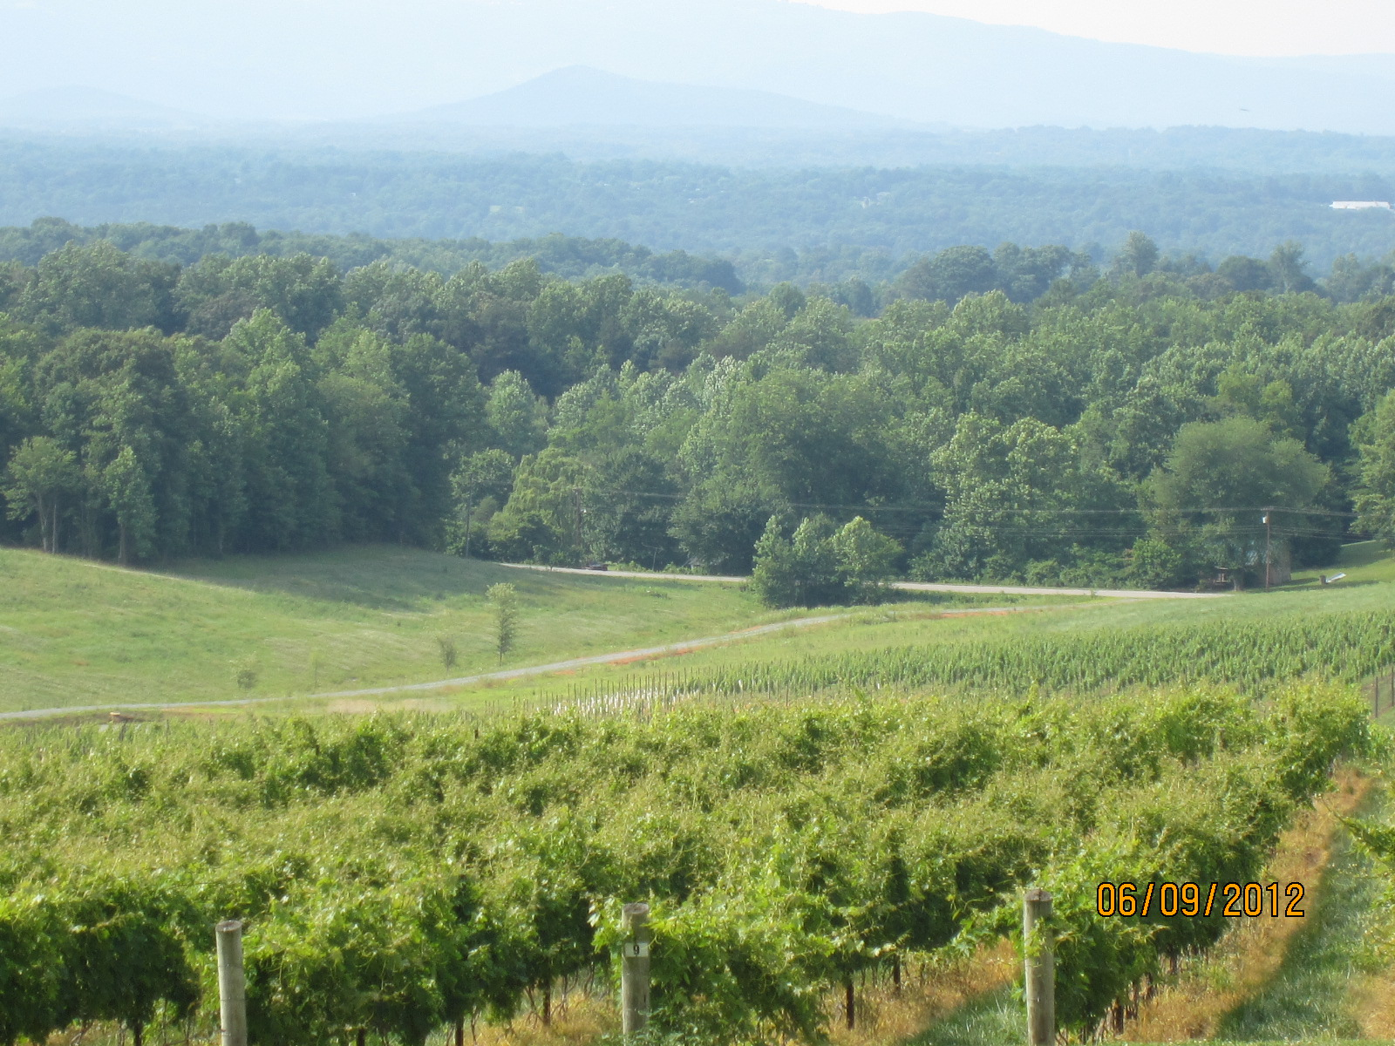
An extremely important part of class is for you to be prepared for class. To do this I expect every student to have read all assigned readings before class. This will give you the background and basis for the class discussion and any activities that are associated with the topic. I will review and discuss some of what is in the readings, but I will not directly lecture the reading. Even if I do not cover it in class you are responsible for any information in the readings and could be tested on it. In addition by reading you will be able to ask questions about the topic that you may want more information or clarification about. I understand that reading takes time and I promise that, if I assign you something to read there is a purpose behind it.

Required:

See Canvas for all readings

Attendance/ Participation

Just like any organization you are expected to attend and participate in all of class. Attendance is a very important part of this class. Over the semester we will be doing a variety of activities, assignments, guest speakers and lectures in class. Many of these will be graded experiences and you need to be in attendance to receive a grade for the activity. In the case of extreme circumstances contact the instructor as soon as possible, preferably before the class that will be missed.

Grading

Grades will be based on an accumulation of a possible 1000 points. The following is how the grade for each assignment will break out in your total grade.

Assignment |  | Points | Percentage of Final Grade
Exams (5 exams over the semester – lowest grade dropped) |  | 400 | 40%
Sustainable Issue Review (Discussions, White Paper, Presentation) |  | 350 | 35 %
Discovery Activities |  | 100 | 10%
Waypoints |  | 100 | 10%
Community Engagement Sustainable Project |  | 50 | 5%

A | 1000 | - | 930 |  | A- | 929.9 | - | 900
B+ | 899.9 | - | 870 |  | B | 869.9 | - | 830 |  | B- | 829.9 | - | 800
C+ | 799.9 | - | 770 |  | C | 769.9 | - | 730 |  | C- | 729.9 | - | 700
D+ | 699.9 | - | 670 |  | D | 669.9 | - | 630 |  | D- | 629.9 | - | 600
F | 599.9 | - | 0
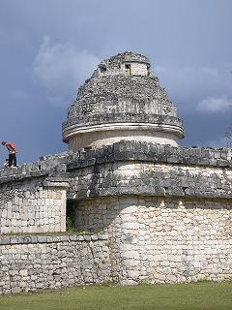
Assignments

Assignment Format:

All assignments, unless otherwise specified, should be turned in typed, in a 12-point font, 1.5 spaced, and grammatically correct. All margins should be set to 1 inch. All pages should be numbered with your name and the date on the first page.

Exam (400 total points)
Throughout the semester there will be 3 exams based on the material covered in the readings, class notes, class activities, guest speakers and class discussions. (SLO 1-7)

Discovery Activities (100 total points)
During the semester students will participate in a number of discussions in small groups. These discussions will span topics including Disney and Paris Climate Accords. Student will contribute to the discussion. (SLO 1-7)

Sustainable Issue Review (330 total points)
Students will select one of the many issues related to sustainable development to research, write about and then make a poster presentation on that issue. Students will need to identify the issue, describe it, discuss what is currently being done, and one way that we can address the issue. (SLO 1-7)

Waypoints (120 total points)
Readings, videos, and class discussion make up the bulk of the course content. To assist with understanding the concepts discussed a series of Waypoints will be done in class for students to complete. These Waypoints will be related to current and past course material. (SLO 1-7)
Community Engagement Sustainable Project (50 points)

All students in the class will assist/work on a sustainable project with a community partner this semester. This project will allow us to address at least one specific issue that is related to sustainability. Also, this partnership will help demonstrate ways that organizations address sustainable issues (SLO 2,4,5,7).
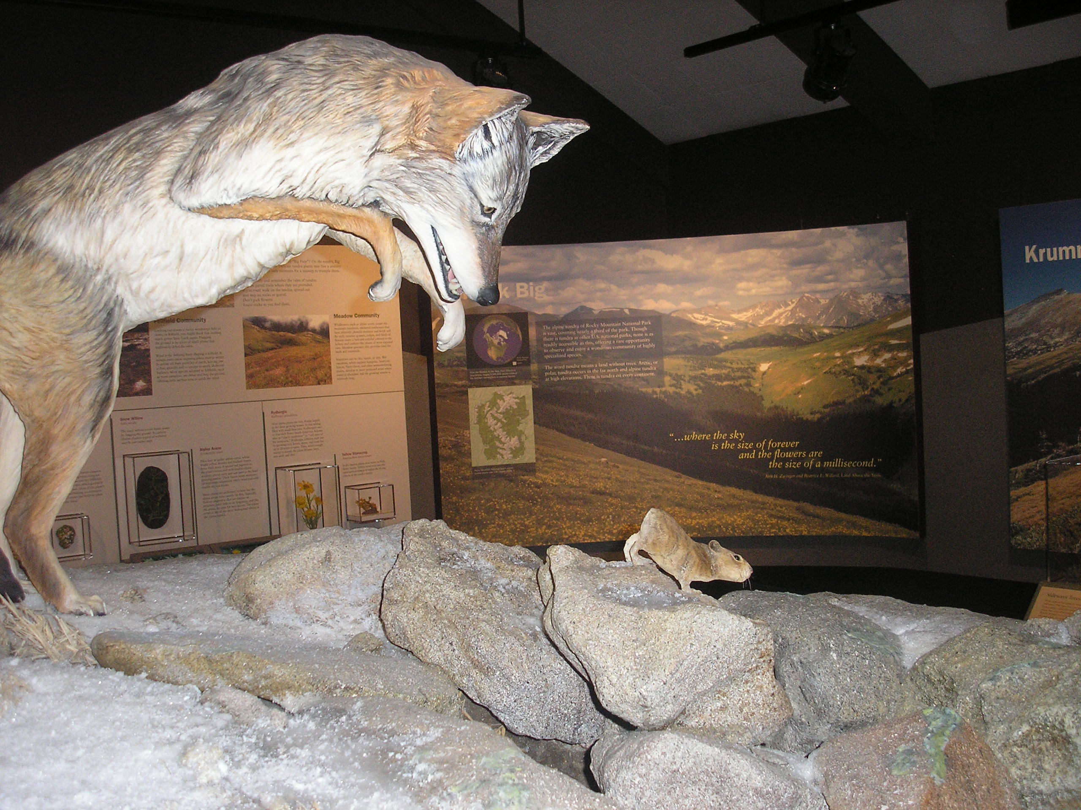

Late Assignments (Excluding Exams)
All assignments are due at the beginning of class on the date indicated. For every hour that the assignment is late 1% of the possible grade will be deducted from the project’s final grade for a maximum of 10% (one letter grade) per day. After 1 week assignments will not be accepted unless prior permission is obtained from the instructor. Late assignments can be turned in to either the instructor’s office or box in Bryan 441. Quizzes and exams will not be accepted late.

Midterm Grades
The midterm grade period occurs each semester between the fifth and sixth week of classes. During this time, I will assign you a midterm grade for this course, which you can access in UNCGenie. Your midterm grade in this course is a snapshot of how you are currently performing academically based on the assignments we have had to date. It will let you know if you are on the right track or if you need to take action to do something differently to improve your grade. If you have a D or an F at the midterm, we should definitely talk further about strategies and options for continuing in the class.

You can find more information about midterm grades on Spartan Central. Once midterm grades are assigned, reach out to me if you have questions. You should also talk with your academic advisor if you are considering withdrawal from this class.

Academic Integrity Policy
By submitting an assignment, each student is acknowledging their understanding and commitment to the Academic Integrity Policy on all major work for the course. Refer to the following URL: https://osrr.uncg.edu/academic-integrity/.

Generative AI Policy
There will be assignments in this class that will encourage the use of Gen AI, others that will not allow its use (i.e. Exams) and assignments that fall in between. Please look to each assignment for details information about the use of AI. The default policy for our course is …

You are expected to follow the University’s Academic Integrity Policy. All ideas, text, images, and other content you submit should be appropriately cited when taken, directly or indirectly, from another source. For purposes of this course, use of generative artificial intelligence (GAI) will be treated analogously to assistance from another person. Unauthorized or unacknowledged collaboration, or the presentation of another’s work as your own, is a violation of the Academic Integrity Policy. If you are unsure about whether particular uses of GAI tools may be plagiarism, cheating, or another form of academic dishonesty, please reach out to me to discuss it as soon as possible.

Accommodations/ADA Statement
The University of North Carolina at Greensboro respects and welcomes students of all backgrounds and abilities. If you encounter any barriers to full participation in this course due to the impact of a disability/condition impacting a major life activity, please contact the Office of Accessibility Resources and Services (OARS). OARS will engage students in an interactive process to determine the need for any reasonable accommodations.

Connect quickly via a brief Welcome Form, https://uncgoars.clockworkportal.com/custom/misc/home.aspx. Upon receipt, OARS will contact you to schedule a convenient, virtual consultation. You may also request a consultation by calling 336-334-5440, emailing oars@uncg.edu, or walking into the OARS suite in 215, EUC. Additional OARS info may be found at https://oars.uncg.edu/.

Religious Obligations Statement
If you need to miss class due to religious obligations, please make arrangements with the instructor in advance. For more information on UNCG’s Religious Obligations policy, visit: UNCG's Religious Obligations Policy.

Attendance Policy for University Sponsored Events
The University recognizes the importance of certain extra-curricular and co-curricular activities (including travel days) that enhance student learning, personal development, and professional growth. Instructors will excuse absences of students for participation in University-sponsored events under the following conditions:
- Students who expect to miss one or more class meetings due to participation in University-sponsored activities should:
  - Notify the instructor(s) at least five class days in advance;
  - Arrange to complete all missed work in advance of the absence whenever practicable as judged by the instructor(s). When missed work cannot be completed in advance, the instructor(s) should provide students with the opportunity to make up the work. Students should be aware, however, that not all kinds of work can be made up. The instructor(s) have the discretion to deny make-up work if (i) alternative assignments place an unreasonable demand on the instructor, (ii) the original assignment is such that not completing it at the originally assigned time impedes student learning
  - Present relevant documentation of participation in a relevant University-sponsored activity to the instructor(s) upon request.

Students who expect to miss more than three class periods of any single course of any kind in a term or more than two consecutive meetings of a laboratory course in order to participate in University-sponsored activities should inform the instructor at the beginning of the course. In the case that the faculty member cannot make reasonable accommodations for make-up work, the student may appropriately be advised to drop the course.

Bryan School Faculty and Student Guidelines

Bryan Faculty and students in this course are expected to adhere to the guidelines stated at this link: https://bryan.uncg.edu/wp-content/uploads/2017/08/Faculty-and-Student-Guidelines-2018-2019.pdf

Midterm Grades:

The midterm grade period for Fall 2023 occurs between September 11-22, 2023. During this time, I will assign you a midterm grade for this course, which you can access in UNCGenie.

Your midterm grade in this course is a snapshot of how you are currently performing academically based on the assignments we have had to date. It will let you know if you are on the right track or if you need to take action to do something differently to improve your grade. If you have a D or an F at the midterm, we should definitely talk further about strategies and options for continuing in the class.

You can find more information about midterm grades here: https://spartancentral.uncg.edu/student-records/grades/ Once midterm grades are assigned, reach out to me if you have questions. You should also talk with your academic advisor if you are considering withdrawal from this class.

Class Schedule
* Subject to Change

Welcome to HTM 200. Below you will find the class schedule, which includes topics we will discuss and the assignments that are due along with the readings that should be completed on the particular date. We will make every attempt to stay on schedule during the semester, but there may come a time when the schedule may get adjusted. Any adjustment to assignment due dates will be announced in class. In addition, if necessary, adjustments need to be made on exams, those will be announced in class and posted to Canvas. Please make sure that you check Canvas weekly (if not daily) for announcements and posted readings. If at any time, you have a question please let me know. I hope each of you have a great semester.

Date | Topic | Assignment Due | Reading/ Video Due
Wednesday 8/20 | Introduction to Class
Monday 8/25 | Unit 1: Overview of Sustainability – History 1 | Waypoint 1 | Read: Our Common Future (pp. 25-38)
Wednesday 8/27 | Unit 1: Overview of Sustainability – History 2 | Discovery Activity 1: Community Pond Activity
Monday 9/1 | LABOR DAY (NO CLASS)
Wednesday 9/3 | Unit 1: Overview of Sustainability – Business Case for Sustainability | Waypoint 2 | Read: Triple Bottom Line  Read: Sustainable Development Goals  Watch: Tragedy of the Commons  Read Language of Sustainable Business pp 27-28  Watch Steve Howard: Let's go all-in on selling sustainability
Monday 9/8 | Exam 1 – On-line | Exam 1
Wednesday 9/10 | Unit 2: Guest Presentation – NC Zoo Presentation |  |  | Watch: Saving animals, saving the future  Watch: How poachers become caretakers
Monday 9/15 | Unit 2: Environmental Dimension | Waypoint 3 |  | Read Ecosystems. Encyclopedia of Sustainability  Watch How you can help save the bees, one hive at a time.  Watch Lessons from a thousand years of island sustainability  Watch the mysterious yellow bottle
Wednesday 9/17 | Unit 2: Environmental Dimension | Discovery Activity 2: Multiple Cultural Views of Env
Monday 9/22 | Unit 3: Aesthetics | Waypoint 4 |  | Watch How public spaces make cities work
Wednesday 9/24 | Exam 2 On-line | Exam 2
Monday 9/29 | Unit 4: Economic Dimension | Waypoint 5 |  | Read: The Sustainable Economy  Read Globalization: Development or Disaster? Encyclopedia of Sustainability
Wednesday 10/1 | Unit 4: Economic Dimension | Discovery Activity 3: Greensboro Glass Recycling Discussion
Monday 10/6 | Unit 5: Social Dimension | Waypoint 6 |  | Read Dempsey_et_al-2011-Sustainable_Development
Wednesday 10/8 | Unit 5: Social Dimension | Discovery Activity 4: Sustainable Disney Discussion |  | Watch - Noy Thrupkaew: Human trafficking is all around you. This is how it works
Monday 10/13 | Fall Break
Wednesday 10/15 | Unit 5: Guest Presentation – Hunger & Food Insecurity |  |  | Watch - A Guerrilla Gardener in South Central LA  Watch: 3 reasons why we can win the fight against poverty
Monday 10/20 | Unit 5: Social Dimension | Waypoint 7
Wednesday 10/22 | Exam 3 On-line | Exam 3
Monday 10/27 | Unit 6: Sustainable Business Strategies | Issue Overview
Wednesday 10/29 | Unit 6: Sustainable Business Strategies | Waypoint 8 |  | Review the 10 Principles of Fair Trade  Read The Role of Business, Consumers, and Investors in Achieving Sustainability in Encyclopedia of Sustainability.  Watch Rob Harmon: How the market can keep streams flowing
Monday 11/3 | Unit 6: Sustainable Business Strategies | Current Solutions
Wednesday 11/5 | Unit 6: Communicating Sustainable Issues with Stakeholders | Waypoint 9 |  | Read – Communicating Sustainable Issues with the Public
Monday 11/10 | Unit 6: Sustainable Business Strategies Review | Task Force Recommendation Discussion Board
Wednesday 11/12 | Exam 4 On-line | Exam 4
Monday 11//17 | Team Work
Wednesday 11/19 | Final Sustainable Issue Paper Due | Final Sustainable Issue Paper Due
Monday 11/24 | Final Sustainable Issue Presentations & Peer Critique | Presentations  Waypoint 10
Monday 12/1 | Final Sustainable Issue Presentations & Peer Critique | Presentations  Waypoint 11
Wednesday 12/3 | Final Sustainable Issue Presentations & Peer Critique | Presentations  Waypoint 12  Team Evaluation
Friday 12/5 | Exam 5 Online | Exam 5

