HTM 332 01

Sustainable Destination and Experience Management

Spring 2026
Monday & Wednesday 3:30 – 4:45
Bryan 216

Instructor: Dr. Erick T Byrd
Email: etbyrd@uncg.edu
Office: Bryan 474
Department Office: Bryan 441

Office Hours: Mondays and Wednesdays 11am – 12:30pm or by appointment

Catalog Description

Students utilize the integration of knowledge and skills in the management of sustainable tourism destinations. Students will be exposed to the entire destination and experience management process including basic concepts, strategic planning, community tourism development, management, and marketing of tourism experiences.

Student Learning Outcomes (SLO)

On completion of this course students will be able to:

- Analyze tourism destinations as interdependent systems, evaluating how attractions, services, marketing, information, and transportation work together to create sustainable visitor experiences.
- Assess the effectiveness of different DMO structures in achieving destination goals, considering their roles in marketing, development, sustainability, and stakeholder coordination.
- Conduct comprehensive destination audits, developing tourism inventories with actionable policy and management recommendations for sustainable development.
- Create strategic tourism plans that integrate destination branding, marketing strategies, and stakeholder engagement to address real-world challenges and opportunities.
- Design and deliver professional destination presentations, showcasing your destination's unique value through visual materials, promotional content, and data-driven insights.
- Apply AI tools and digital technologies to enhance destination management, marketing, and visitor experience design while maintaining ethical practices.

Texts:

Required

Morrison, A.M., Lehto, X.Y. & Day, J.G. (2018). The tourism system (8th ed.). Dubuque, Iowa: Kendall/Hunt Publishing.

Attendance

Just like any organization would expect you to show up for work, I expect you to attend class. This class is based on student preparation and participation. Therefore, attendance is a very important part of this class. If you miss class, you are still responsible for all material covered in class. If you must miss class for a valid reason, please contact me as soon as possible.

Grading

The following is how the grade for each assignment will brake out in your total grade.

Assignment |  | Points |  | Assignment |  | Points
Class Activity (10) |  | 100 |  | Tourism Resource Assessment |  | 200
Worksheets |  | 100 |  | Strategic Plan |  | 250
Exams (2) |  | 200 |  | Showcase |  | 100
Hands-on Experience |  | 50

A | 1000 | - | 930 |  | A- | 929 | - | 900
B+ | 899 | - | 870 |  | B | 869 | - | 830 |  | B- | 829 | - | 800
C+ | 799 | - | 770 |  | C | 769 | - | 730 |  | C- | 729 | - | 700
D+ | 699 | - | 670 |  | D | 669 | - | 630 |  | D- | 629 | - | 600
F | 599 | - | 0

Explanation of Letter Grade

A/A- Achievement of distinction and excellence
B+/B/B- General achievement superior to an average standard
C+/C/C- Acceptable, average ability reflecting reasonable time and effort
D+/D/D- Falls below acceptable standards but is sufficient to be counted
F Failure; not a passing grade
I A grade of Incomplete will not be given in this course

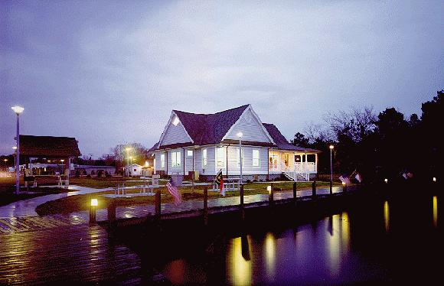
Assignments
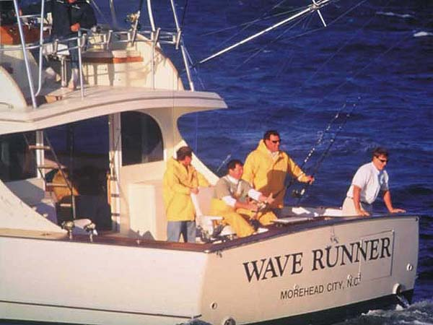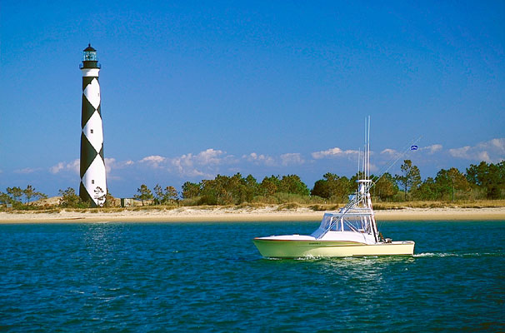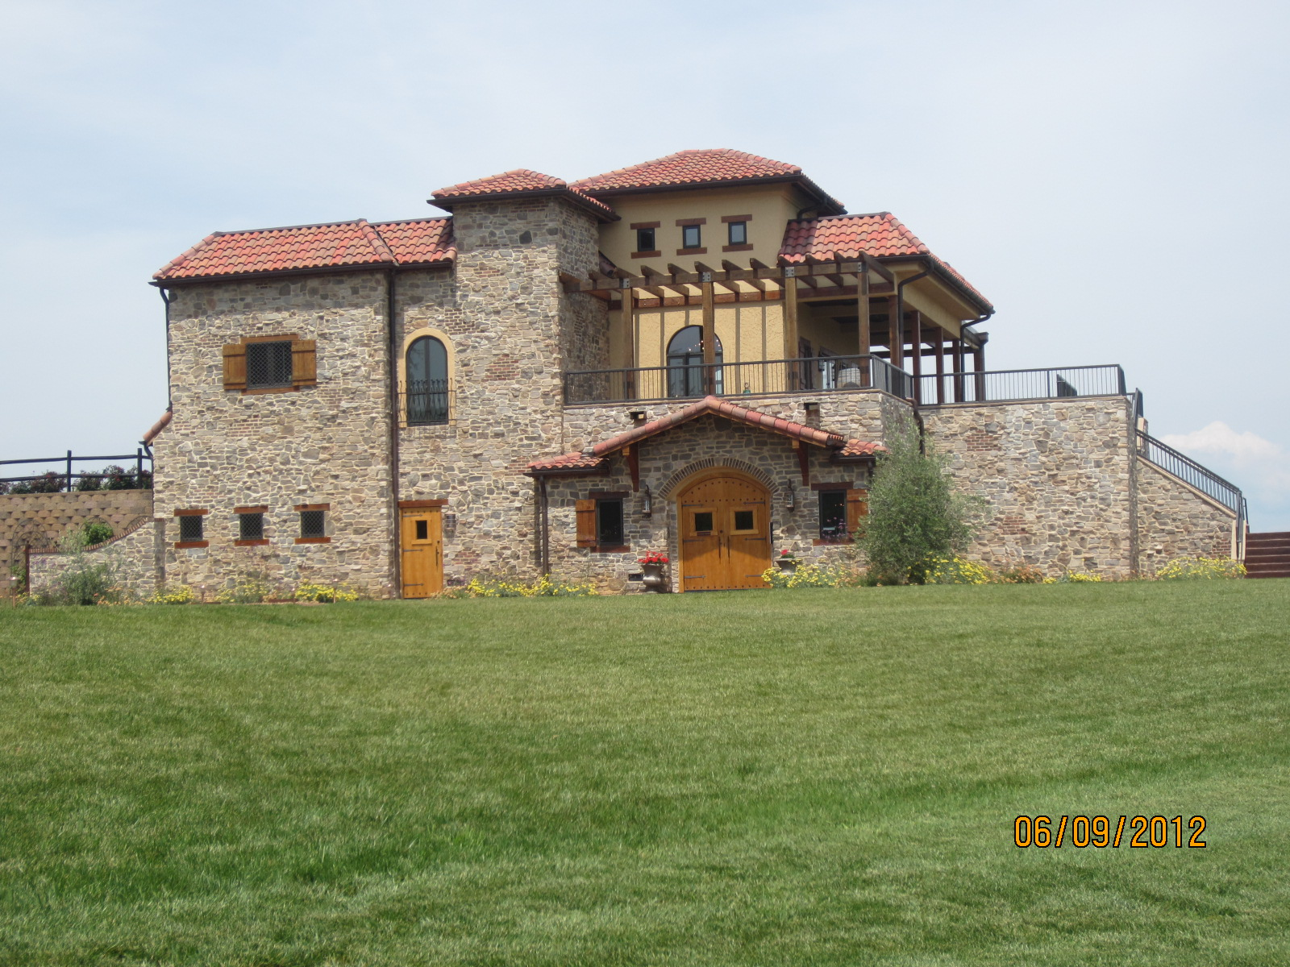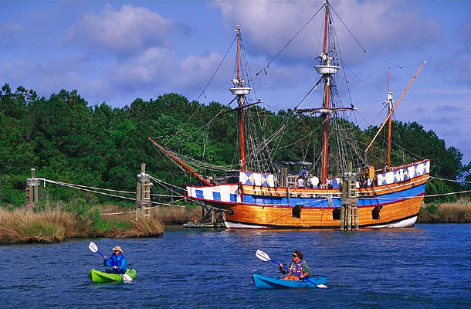Assignment Format:
All assignments, unless otherwise specified, should be turned in typed, in a 12-point font, grammatically correct and in standard format. All margins should be set to 1 inch. All pages should be numbered with your name and the date on the first page. Additional information will be given during class for each assignment. Any assignment that does not meet format requirements will be lowered by 1 letter grade.

Class Activity (100 points)
During class students will participate in a variety of activities that are related to managing a destination. These activities will come in the form of short presentations, case studies, and group work. The activities will relate to the topic being discussed during the class. (SLO 1-9)

Worksheets (100 points)
To help you with the course material there will be short Worksheets throughout the semester. The quiz will pertain to previous class discussions, previous and current readings, and previous presentations. (SLO 1-9)

Inventory & Audit (200 points)
Students will be given a destination to develop a comprehensive tourism resource audit. The audit will focus specifically on the resources of the destination. (SLO 1, 4-6)

Strategic Plan (250 points)
Each student will develop a strategic plan for the destination that they are assigned. This plan will include the development of goals and objectives for the destination as well as a marketing plan for the destination. Each student will make a presentation about their destination. The presentation will include an analysis of decisions made during the semester in class activities, experiences during the trade show, and their thoughts of the future of their destination. (SLO 1-8)

Showcase (100 points)
You will be participating in a mock showcase/tradeshow. For this show the you will be required to develop a visuals and promotional material. You will manage your presentation (SLO 1, 2, 4, 6, 8)

Exams (200 points)
Throughout the semester there will be 2 exams based on the material covered in the readings, class notes, class activities, guest speakers and class discussions. (SLO 1-6)

Destination Management Hands-on Experience (200 points):
To gain an understanding of the multiple elements involved in destination management students are required to assist in the operations of an event. This assignment will require students to assist with an event followed by a written reflection of that experience. More information about this assignment will be discussed in class and available on Canvas (SLO: 1-6).

Late Assignments (Excluding Worksheets)
All assignments are due at the beginning of class on the date indicated. For every hour that the assignment is late 1% of the possible grade will be deducted from the project’s final grade for a maximum of 10% (one letter grade) per day. After 1 week, assignments will not be accepted unless prior permission is obtained from the instructor. Late assignments can be turned in to either the instructor’s office or box in Bryan 441. Quizzes will not be accepted late.

Academic Integrity Policy
By submitting an assignment, each student is acknowledging their understanding and commitment to the Academic Integrity Policy on all major work for the course. Refer to the following URL: https://osrr.uncg.edu/academic-integrity/.

Accommodations/ADA Statement
UNCG seeks to comply fully with the Americans with Disabilities Act (ADA). Students requesting accommodations based on a disability must connect with the Office of Accessibility Resources and Services (OARS) in 215 Elliott University Center, (336)334-5440, oars.uncg.edu.

Religious Obligations Statement
State how you make accommodations and what your policy for advance notification any required make-up work. For more information on UNCG’s Religious Obligations policy, visit: https://catalog.uncg.edu/academic-regulations-policies/university-policies/

Attendance Policy for University Sponsored Events
The University recognizes the importance of certain extra-curricular and co-curricular activities (including travel days) that enhance student learning, personal development, and professional growth. Instructors will excuse absences of students for participation in University-sponsored events under the following conditions:
- Students who expect to miss one or more class meetings due to participation in University-sponsored activities should:
  - Notify the instructor(s) at least five class days in advance;
  - Arrange to complete all missed work in advance of the absence whenever practicable as judged by the instructor(s). When missed work cannot be completed in advance, the instructor(s) should provide students with the opportunity to make up the work. Students should be aware, however, that not all kinds of work can be made up. The instructor(s) have the discretion to deny make-up work if (i) alternative assignments place an unreasonable demand on the instructor, (ii) the original assignment is such that not completing it at the originally assigned time impedes student learning
  - Present relevant documentation of participation in a relevant University-sponsored activity to the instructor(s) upon request.

Students who expect to miss more than three class periods of any single course of any kind in a term or more than two consecutive meetings of a laboratory course in order to participate in University-sponsored activities should inform the instructor at the beginning of the course. In the case that the faculty member cannot make reasonable accommodations for make-up work, the student may appropriately be advised to drop the course.

Bryan School Faculty and Student Guidelines

Bryan Faculty and students in this course are expected to adhere to the guidelines stated at this link: https://bryan.uncg.edu/wp-content/uploads/2017/08/Faculty-and-Student-Guidelines-2018-2019.pdf

Class Schedule
*Subject to change

Welcome to a new semester and to HTM 332. Below you will find the class schedule, which includes topics we will discuss and the assignments that are due along with the readings that should be completed on the particular date. We will make every attempt to stay on schedule during the semester, but there may come a time when the schedule may get adjusted. Any adjustment to assignment due dates will be announced in class. Please make sure that you check Canvas weekly (if not daily) for announcements and posted readings. If at any time, you have a question please let me know. I hope each of you have a great semester.

Date | Topic | Assignment Due | Reading/ Video Due
Monday 1/12 | Introduction to Class
Wednesday 1/14 | Concept of Place, Hospitality, and a Tourism Destination | Worksheet 1 | Chapter 1: pp 3-10  Canvas Reading 1:  The Tourism Market Basket of Goods and Services
Monday 1/19 | No Class (Holiday)
Wednesday 1/21 | Supply Side: Identifying and Assessing Hospitality and Tourism Resources |  | Chapter 1: pp 15-35
Monday 1/26 | Supply Side: Identifying and Assessing Hospitality and Tourism Resources
Wednesday 1/28 | Supply Side: Identifying and Assessing Hospitality and Tourism Resources: Tourism Resource Audit | Worksheet 2 | Chapter 17
Monday 2/2 | Supply Side: What is a Destination/ Understanding Tourism Impacts | Worksheet 3 |  | Chapter 2
Wednesday 2/4 | Destination Management Organization and Structure | Class Activity 1  (Who Are you) |  | Mill & Morrison:  Chps 3-4  Canvas Reading 2-5:  Johnston County, City of Cary, Union County, Burke County
Monday 2/9 | Destination Management Organization and Structure - Tourism Policy
Wednesday 2/11 | Destination Management Organization and Structure – Advocacy | Class Activity 2  (What is your policy/ mission)
Monday 2/16 | Destination Management Organization and Structure cont. | Worksheet 4
Wednesday 2/18 | No Class – Exam 1 | Exam 1
Monday 2/23 | Demand | Worksheet 5 |  | Chapter 7 (pp 198-206); 10 & 12, 13 & 14
Wednesday 2/25 | Demand | Class Activity 3  (Who Do We Want To Invite?) |  | Chap 10 & 12
Monday 3/2 | Strategic Tourism Planning | Worksheet 6 |  | Chapter 5 & 6
Wednesday 3/4 | Strategic Tourism Planning | Class Activity 4 (SWOT)
Monday 3/9 | Spring Break
Wednesday 3/11 | Spring Break
Monday 3/16 | Strategic Tourism Planning | Tourism Resource Assessment Due  Class Activity 5  (Goals and Objectives)
Wednesday 3/18 | Marketing: Linking supply to demand |  |  | Chapter 7
Monday 3/23 | Marketing: Linking supply to demand (the Experience) | Worksheet 7 |  | Chapters 9 & 11
Wednesday 3/25 | Experience | Class Activity 6
Monday 3/30 | Fine Wines
Wednesday 4/1 | Fine Wines
Monday 4/6 | Marketing: Linking supply to demand | Worksheet 8
Wednesday 4/8 | Marketing Promotions | Worksheet 9 |  | Chapter 8
Monday 4/13 | Marketing Promotional Material | Class Activity 7  (Brochure Development)
Wednesday 4/15 | Marketing Promotional Material | Class Activity 8  (Ads)
Monday 4/20 | Marketing Promotional Material | Worksheet 10
Wednesday 4/22 | Consultation Session
Monday 4/27 | Consultation Session | Strategic Plan Due by 5:00 pm
Wednesday 4/29 | Showcase | Final Presentations
Exam | HTM 433 – Wednesday 5/6 @ 3:30 | Exam 2

