HTM 433 01
Event, Meeting and Esports Tourism
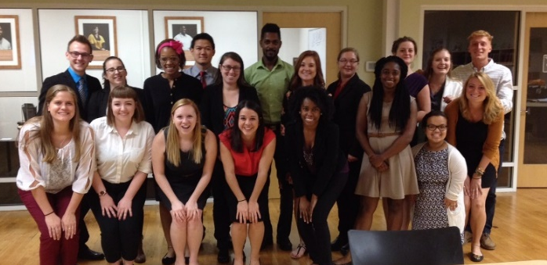
Spring 2026
Monday & Wednesday
2:00 – 3:15
Bryan 216

Instructor: Dr. Erick T Byrd
Email: etbyrd@uncg.edu
Office: 474 Bryan Building

Office Hours: Mondays and Wednesdays 11am – 12:30pm or by appointment

Catalog Description

Explores event management from the tourism and Esports perspective with a focus on destination event portfolios. Students learn to plan and execute these events and develop a community event portfolio management.

Student Learning Outcomes (SLO)

On completion of this course students will be able to:

- Design and execute events that align with community needs and stakeholder objectives
- Develop and evaluate event portfolios that maximize community impact through strategic planning.
- Apply contemporary marketing strategies and digital technologies to promote events and enhance attendee experiences
- Evaluate event tourism trends, consumer segments, and industry best practices to inform strategic decision-making
- Organize and conduct special events and meetings in a variety of settings.
- Apply AI tools and digital technologies to enhance event design management, marketing, and guest experience design while maintaining ethical practices

Texts

Bladen, C., Kennell, J., Abson, E. and Wilde, N. (2023). Events Management: An Introduction (3rd Ed). Routledge..

Attendance
Just like any organization would expect you to show up for work, I expect you to attend class. This class is based on student preparation and participation. Therefore, attendance is a very important part of this class. If you miss class, you are still responsible for all material covered in class. If you miss class for a valid reason, please contact me as soon as possible.

Grading

The following is how the grade for each assignment will break out in your total grade.

Assignment |  | Points
Exam (100 points each) |  | 300
Worksheets |  | 100
Event Proposal |  | 100
Event Type Presentation |  | 50
Event Hands-on Experience |  | 300
Community Event Portfolio |  | 150
Total |  | 1000

A | 1000 | - | 930 |  | C+ | 799 | - | 770
A- | 929 | - | 900 |  | C | 769 | - | 730
B+ | 899 | - | 870 |  | C- | 729 | - | 700
B | 869 | - | 830 |  | D+ | 699 | - | 670
B- | 829 | - | 800 |  | D | 669 | - | 630
 |  |  |  |  | D- | 629 | - | 600
 |  |  |  |  | F | 599 | - | 0

Explanation of Letter Grade

A/A- Achievement of distinction and excellence
B+/B/B- General achievement superior to an average standard
C+/C/C- Acceptable, average ability reflecting reasonable time and effort
D+/D/D- Falls below acceptable standards but is sufficient to be counted
F Failure; not a passing grade

Assignments

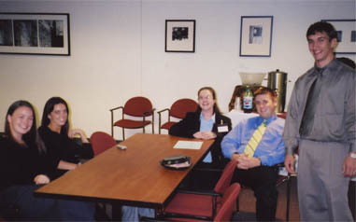
Assignment Format:

All assignments, unless otherwise specified, should be turned in typed, in a 12-point font, 1.5 spaced, and grammatically correct. All margins should be set to 1 inch. All pages should be numbered with your name and the date on the first page. Written assignments should be submitted via Canvas by due date and time.

Exams (300 points)
Throughout the semester there will be 3 exams based on the material covered in the readings, class notes, class activities, guest speakers and class discussions. (SLO 1-6)

Worksheets (Checkpoint) (100 total points)
Readings, videos, and class discussion make up the bulk of the course content. To assist with understanding the concepts discussed a series of Worksheets will be done in class. These Worksheets will be related to current and past course material. (SLO 1-7)

Event Hands-on Experience (200 points):
To gain an understanding of the multiple elements involved in events, Esport events and meetings students are required to assist in the operations of three events. This assignment will require students to assist in an event followed by a written reflection of that experience. More information about this assignment will be discussed in class and available on Canvas (SLO: 1,3,5,6).

Event Proposal Development (100 points)
Students will develop a proposal for a new event. During the semester specific assignments will be turned in (SLO 1-6):

Event Type Presentation: (50 points)
Students will be assigned an event type to research and develop a presentation to present to the class along with a one-page fact sheet about the event type. The presentation will be approximately 10 min. (SLO 2-4,7)

Community Event Portfolio: (150 points)
Students will be assigned a community to develop an event inventory and portfolio. Students will then develop recommendations for the community to enhance their current event portfolio. (SLO 1,2,4,6)

Late Assignments
A very important part of being a professional is meeting deadlines. All assignments are due at the beginning of class (3:30 pm) on the date indicated unless otherwise specified by the instructor. Late assignments will not be accepted without permission from the instructor.

Academic Integrity Policy
By submitting an assignment, each student is acknowledging their understanding and commitment to the Academic Integrity Policy on all major work for the course. Refer to the following URL: https://osrr.uncg.edu/academic-integrity/.

Accommodations/ADA Statement
UNCG seeks to comply fully with the Americans with Disabilities Act (ADA). Students requesting accommodations based on a disability must connect with the Office of Accessibility Resources and Services (OARS) in 215 Elliott University Center, (336)334-5440, oars.uncg.edu.

Religious Obligations Statement
State how you make accommodations and what your policy for advance notification any required make-up work. For more information on UNCG’s Religious Obligations policy, visit: https://catalog.uncg.edu/academic-regulations-policies/university-policies/

Attendance Policy for University Sponsored Events
The University recognizes the importance of certain extra-curricular and co-curricular activities (including travel days) that enhance student learning, personal development, and professional growth. Instructors will excuse absences of students for participation in University-sponsored events under the following conditions:
- Students who expect to miss one or more class meetings due to participation in University-sponsored activities should:
  - Notify the instructor(s) at least five class days in advance;
  - Arrange to complete all missed work in advance of the absence whenever practicable as judged by the instructor(s). When missed work cannot be completed in advance, the instructor(s) should provide students with the opportunity to make up the work. Students should be aware, however, that not all kinds of work can be made up. The instructor(s) have the discretion to deny make-up work if (i) alternative assignments place an unreasonable demand on the instructor, (ii) the original assignment is such that not completing it at the originally assigned time impedes student learning
  - Present relevant documentation of participation in a relevant University-sponsored activity to the instructor(s) upon request.

Students who expect to miss more than three class periods of any single course of any kind in a term or more than two consecutive meetings of a laboratory course in order to participate in University-sponsored activities should inform the instructor at the beginning of the course. In the case that the faculty member cannot make reasonable accommodations for make-up work, the student may appropriately be advised to drop the course.

Bryan School Faculty and Student Guidelines

Bryan Faculty and students in this course are expected to adhere to the guidelines stated at this link: https://bryan.uncg.edu/wp-content/uploads/2017/08/Faculty-and-Student-Guidelines-2018-2019.pdf

Legal Notice for Course Recordings
This course will be recorded so we may archive it for re-broadcast for the online section of this class and for those unable to attend. If you are participating/view webcast (zoom, google chat, etc.) and do not wish to be recorded, please turn off your camera and mute your microphone. You may still use the chat to participate. If you are attending this course in person and do not wish to be recorded, please advise me of that, and all efforts will be made not to record your participation.

Class Schedule
*Subject to change

Welcome to a new semester and to HTM 433. Below you will find the class schedule, which includes topics we will discuss, field trips, and the assignments that are due along with the readings that should be completed on the particular date. We will make every attempt to stay on schedule during the semester, but there may come a time when the schedule may get adjusted. Please note that this course will have material presented in both in class, on-line formats and out of class formats, so make sure you keep up with all material and assignments. Any adjustment to assignment due dates will be announced in class. Please make sure that you check Canvas weekly (if not daily) for announcements and posted readings. If at any time, you have a question please let me know. I hope each of you have a great semester.

Date | Topic | Assignment Due | Reading/ Video Due
Monday 1/12 | Introduction to Class
Wednesday 1/14 | Events: What are they, why are they important, and who is involved | Worksheet 1 | Chapter 1
Monday 1/19 | No Class (Holiday)
Wednesday 1/21 | Event Strategic Planning & Project Management: Mission Based Planning | Worksheet 2 Activity 1: Mission | Chapter 2
Monday 1/26 | Event Strategic Planning & Project Management: Project Planning | Worksheet 2 Activity 2: Goals & Objectives
Wednesday 1/28 | Event Planning Guest Speakers – NC Fine Wines | Guest Speakers
Monday 2/2 | Event Strategic Planning & Project Management: Project Leadership | Worksheet 2 Due
Wednesday 2/4 | Exam 1 | Exam 1
Monday 2/9 | Event Design | Worksheet 3 Activity 3 |  | Chapter 3
Wednesday 2/11 | Event Operations & Sight Planning |  |  | Chapter 4
Monday 2/16 | MEHT Career Event
Wednesday 2/18 | Online - Event Human Resources & Volunteers |  |  | Chapter 5
Monday 2/23 | Event Finance |  |  | Chapter 6
Wednesday 2/25 | Event Marketing |  |  | Chapter 7
Monday 3/2 | Event Marketing | Worksheet 3 Activity 4
Wednesday 3/4 | Exam 2
Monday 3/9 | Spring Break | Proposal Work
Wednesday 3/11 | Spring Break
Monday 3/16 | Event Proposal Paper Due | Event Proposal Paper
Wednesday 3/18 | NC Fine Wines Competition Overview
Thursday 3/19 | MEHT GALA
Monday 3/23 | Stakeholders. Communities and Events
Wednesday 3/25 | Event Portfolios | Worksheet 4
Monday 3/30 | Fine Wines
Wednesday 4/1 | Fine Wines
Monday 4/6 | Event Experience Debrief and Review | Event Experience Journal Reflection Paper
Wednesday 4/8 | Event Type Presentations |  |  | Chapters 9-13
Monday 4/13 | Community Event Portfolio Work
Wednesday 4/15 | Outcomes – Evaluating Events |  |  | Chapter 14
Monday 4/20 | Outcomes – Evaluating Events – Economic Impact | Worksheet 5
Wednesday 4/22 | Community Event Portfolio Work
Monday 4/27 | Community Event Portfolio Work | Community Event Portfolio Paper
Wednesday 4/29 | Community Event Portfolio Presentations | Community Event Portfolio Presentations
Exam | HTM 433 – Wednesday 5/6 @ 12:00 | Exam 3

